# **Date: 2021-02-26**

## Researchers involved in measurements:

Scott, Cameron, and Ben

# **Goal:**

Test the attenuation as the hydrophones get further and further apart in the y-direction in the tank, but centered in the x and z direction.

# **Equipment specifics:**

## Anechoic lining position –

All located on the Ymax side of the tank. Arranged in a U-shape attempting to not create an image source for AEgir being the stationary source.

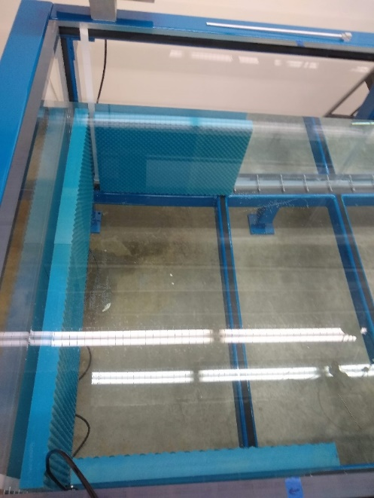

## Water level:

0.48 m

## Water Temperature:

19 degrees C (according to ducky)

## Hydrophones -

BK 8103 (Aegir) (Source)   
BK 8013 (Ran) (Receiver)

## Source:

BK 8103 (Aegir) (Source)  
Ch 0 (Sea)

3000mV output

### Amplifier:

TEGAM - 7200

### Impedance matching transformer: (Y/N)

Y - 7301

## Receiver(s):

BK 8013 (Ran) (Receiver)  
Ch0 (TEGAM Monitor) +-2V Low  
Ch1 (BK8103, NEXUS Ch2 Preamp) +-10V High

## Preamplifier:

NEXUS – Ch2

Preamplifier Settings-  
Sensitivity 0.101 pC/Pa; 10mV/Pa

The preamp is not connected to ground. (will need to test connecting this to ground in the future to see if this deals with the DC offset effectively.)

# **Signal:**

## Sampling frequency:

1MHz

## Signal type:

Linear Chirp

## Frequency band:

10kHz – 100kHz

## Signal length:

0.5s zeroes, 2s Signal, 0.5s zeroes

**Scan:**

## Settling time:

10s

## Ægir Position(s)

X = 0.6

Y= 2.14

Z=0.24

## Rán Position(s)

X=0.6

Y=2.06 - 0.5 (5 points)

Z=0.332

## File Path:

W:\uw-measurements-tank\2021-02-26\2021-02-26_scan3

## Scan3:

Output: 3000mV  
Input: CH0 +- 2V Low, CH1 +-10V High

Looks really good. Definitely see reduced energy with distance.

**Result:** (What scans are best to look at? Where to go next? Important discoveries? Identify any invalid scans)

Scan3 (scan4 is also great for future reference. Scan4 does 10 points instead of 5.)